LAB 4
4.1) Insert the new node with the given data at the beginning of the list.
CODE:
#include <stdio.h>
#include <stdlib.h>

// Define structure for a node
struct Node {
int data;
struct Node *next;
};

// Head pointer (initially NULL)
struct Node *head = NULL;

// Function to insert at beginning
void insert_at_beginning(int data) {
// Create new node
struct Node *newNode = (struct Node*)malloc(sizeof(struct Node));

// Assign data
newNode->data = data;

// Make new node point to current head
newNode->next = head;

// Move head to new node
head = newNode;
}

// Function to display list
void display() {
struct Node *temp = head;
while (temp != NULL) {
printf("%d -> ", temp->data);
temp = temp->next;
}
printf("NULL\n");
}

int main() {
insert_at_beginning(11);
insert_at_beginning(22);
insert_at_beginning(33);
insert_at_beginning(44);
insert_at_beginning(55);

printf("Linked List:\n");
display();

return 0;
}
EXECUTION:
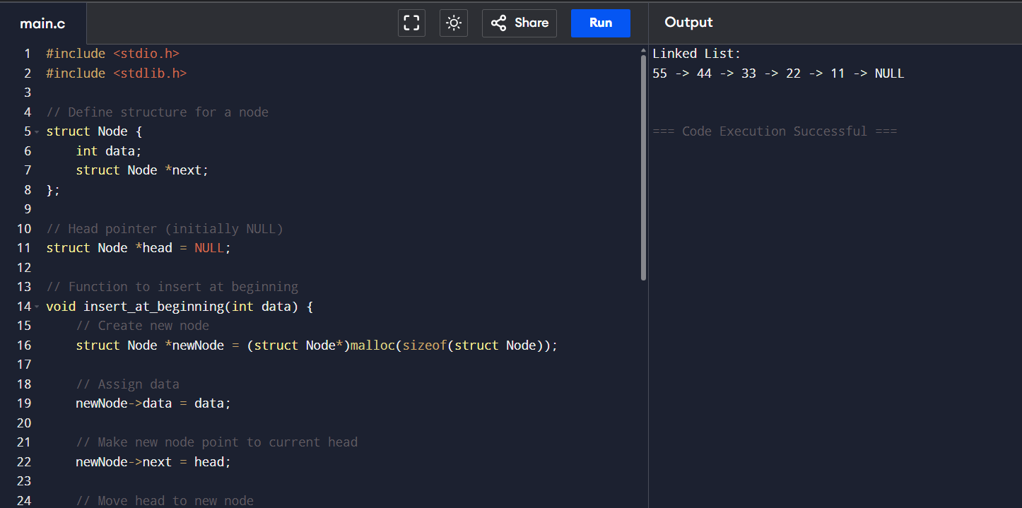

4.2) Insert the new node with the given data at the end of the list.
CODE:
#include <stdio.h>
#include <stdlib.h>

struct Node {
int data;
struct Node *next;
};

struct Node *head = NULL;

// insert at beginning
void insert_at_beginning(int data) {
struct Node *newNode = (struct Node*)malloc(sizeof(struct Node));
newNode->data = data;
newNode->next = head;
head = newNode;
}

// insert at end
void insert_at_end(int data) {
struct Node *newNode = (struct Node*)malloc(sizeof(struct Node));
newNode->data = data;
newNode->next = NULL;

if (head == NULL) {
head = newNode;
return;
}

struct Node *temp = head;
while (temp->next != NULL) {
temp = temp->next;
}
temp->next = newNode;
}

// display list
void display() {
struct Node *temp = head;
while (temp != NULL) {
printf("%d -> ", temp->data);
temp = temp->next;
}
printf("NULL\n");
}

// free linked list
void free_list() {
struct Node *temp;

while (head != NULL) {
temp = head;
head = head->next;
free(temp);
}
}

int main() {
insert_at_end(10);
insert_at_end(11);
insert_at_end(12);
insert_at_end(13);
insert_at_end(14);
insert_at_end(15);

printf("Linked List:\n");
display();

free_list();

return 0;
}

EXECUTION:
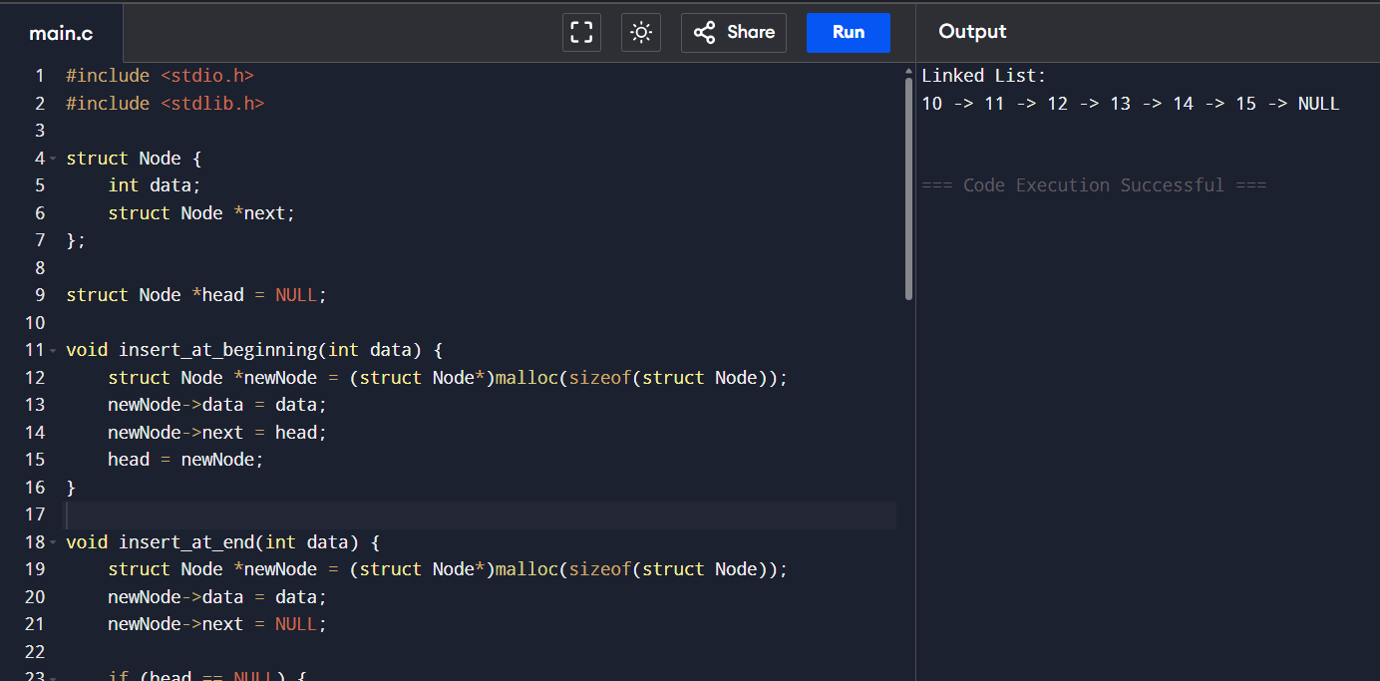

4.3) Delete the first node in the list that contain the given data.
CODE:
#include <stdio.h>
#include <stdlib.h>

// Define Node structure
struct Node {
int data;
struct Node *next;
};

// Head pointer
struct Node *head = NULL;

// Insert at end
void insert_at_end(int data) {
struct Node *newNode = (struct Node*)malloc(sizeof(struct Node));
newNode->data = data;
newNode->next = NULL;

if (head == NULL) {
head = newNode;
return;
}

struct Node *temp = head;
while (temp->next != NULL) {
temp = temp->next;
}
temp->next = newNode;
}

// Delete first node containing given data
void delete_node(int data) {
struct Node *temp = head;
struct Node *prev = NULL;

// Case 1: If head node contains data
if (temp != NULL && temp->data == data) {
head = temp->next;
free(temp);
return;
}

// Search for node to delete
while (temp != NULL && temp->data != data) {
prev = temp;
temp = temp->next;
}

// If data not found
if (temp == NULL) {
printf("Value %d not found in list.\n", data);
return;
}

// Unlink node
prev->next = temp->next;
free(temp);
}

// Display list
void display() {
struct Node *temp = head;
while (temp != NULL) {
printf("%d -> ", temp->data);
temp = temp->next;
}
printf("NULL\n");
}

// Free entire list
void free_list() {
struct Node *temp;
while (head != NULL) {
temp = head;
head = head->next;
free(temp);
}
}

int main() {

// Insert numbers
insert_at_end(10);
insert_at_end(11);
insert_at_end(12);
insert_at_end(13);
insert_at_end(14);
insert_at_end(15);

printf("Original List:\n");
display();

// Delete a value
delete_node(12);

printf("After Deleting 12:\n");
display();

free_list();

return 0;
}
EXECUTION:
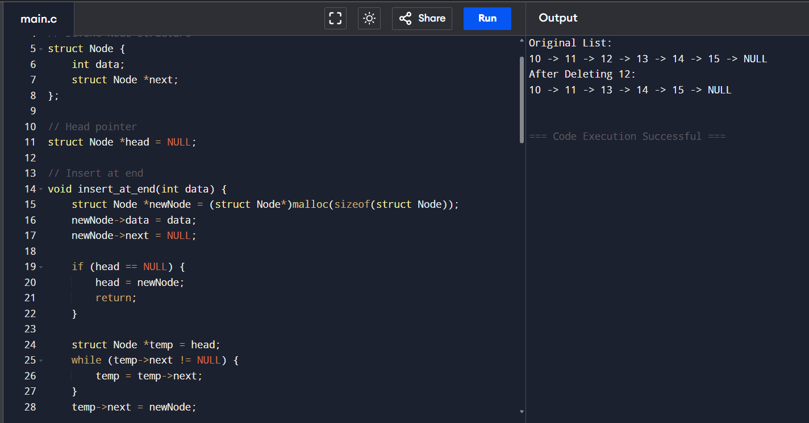

4.4) Traverse the list and print the data of each node.
CODE:
#include <stdio.h>
#include <stdlib.h>

// Define Node structure
struct Node {
int data;
struct Node *next;
};

// Head pointer
struct Node *head = NULL;

// Insert at end
void insert_at_end(int data) {
struct Node *newNode = (struct Node*)malloc(sizeof(struct Node));
newNode->data = data;
newNode->next = NULL;

if (head == NULL) {
head = newNode;
return;
}

struct Node *temp = head;
while (temp->next != NULL) {
temp = temp->next;
}
temp->next = newNode;
}

// Traverse and print list
void traverse() {
struct Node *temp = head;

if (temp == NULL) {
printf("List is empty.\n");
return;
}

printf("Linked List: ");
while (temp != NULL) {
printf("%d ", temp->data);
temp = temp->next;
}
printf("\n");
}

// Free memory
void free_list() {
struct Node *temp;
while (head != NULL) {
temp = head;
head = head->next;
free(temp);
}
}

int main() {

// Insert numbers
insert_at_end(10);
insert_at_end(11);
insert_at_end(12);
insert_at_end(13);
insert_at_end(14);
insert_at_end(15);

// Traverse list
traverse();

free_list();

return 0;
}
EXECUTION:
